Activity 4: Weather Forecast Web Application

This project is a Weather Forecast App that displays real-time weather information for any city using data fetched from the OpenWeatherMap API through a NestJS backend proxy. It shows the current temperature, weather condition, and dynamically updates icons (sunny, rainy, cloudy, etc.) based on live weather data. The React frontend provides a clean and responsive interface, where users can easily search for a city and view its weather detail
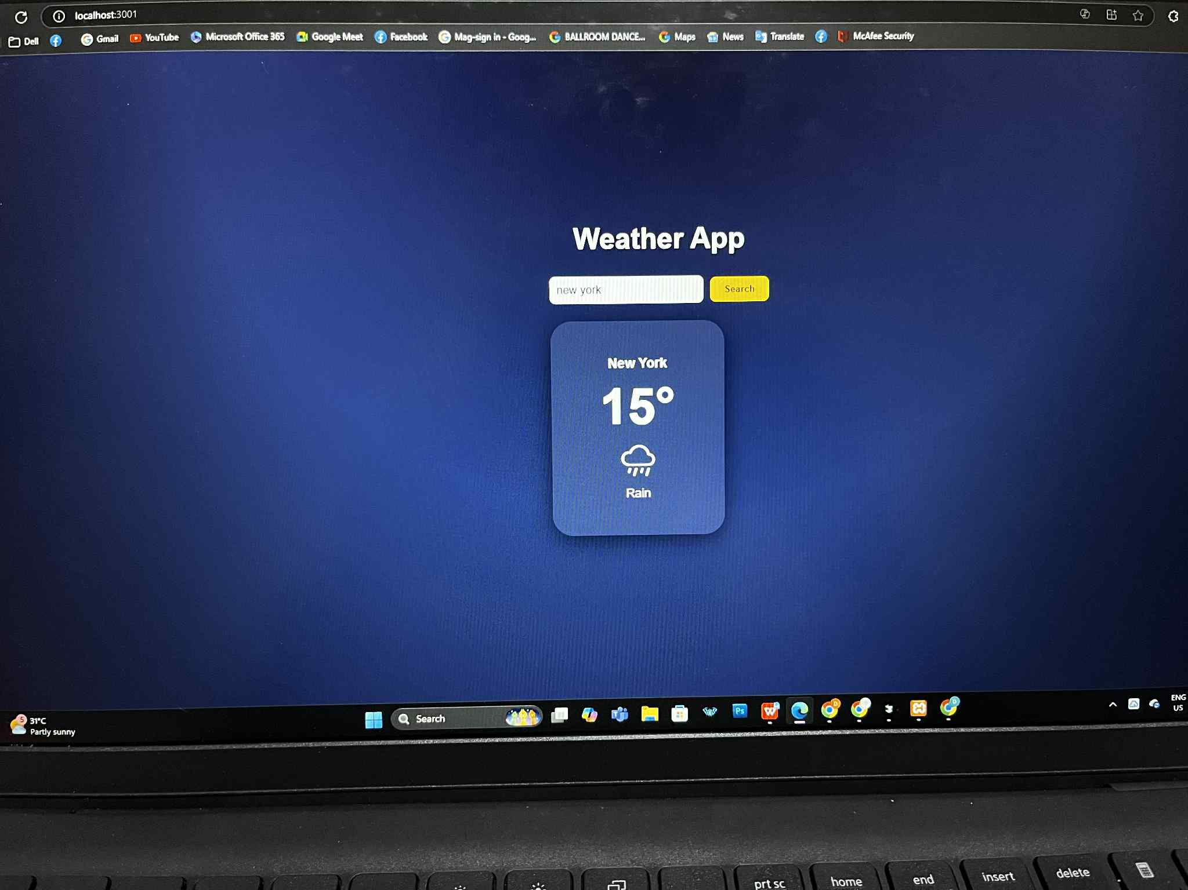

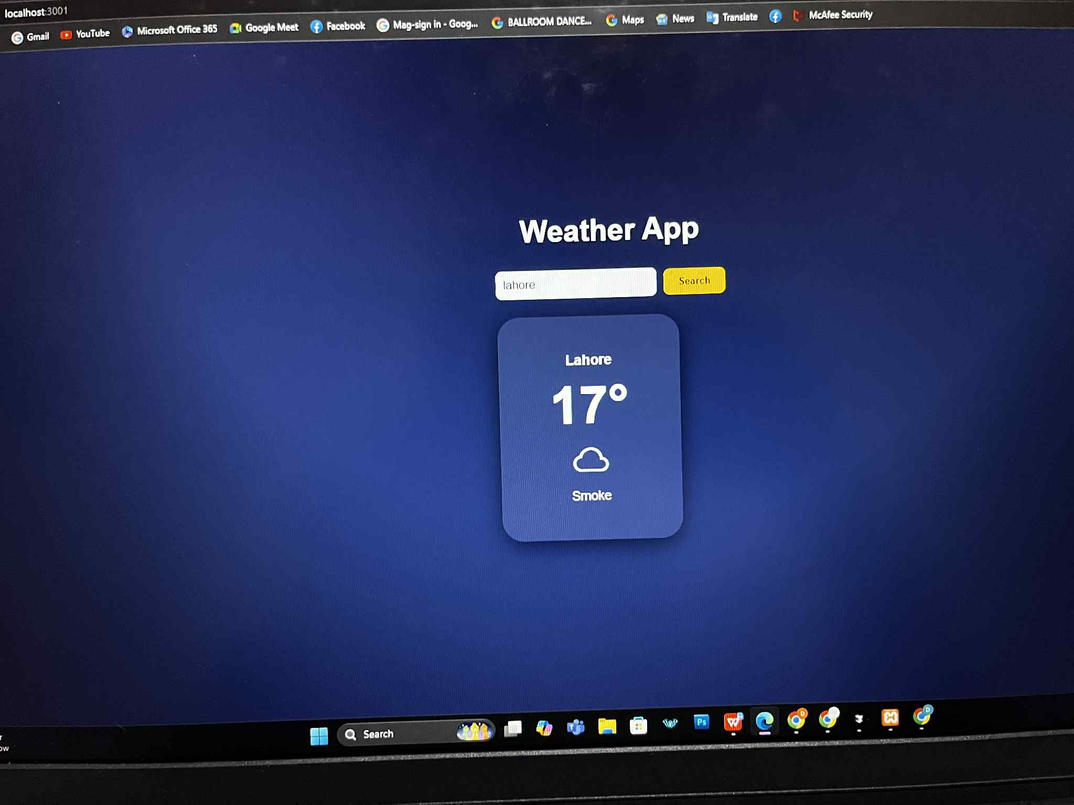
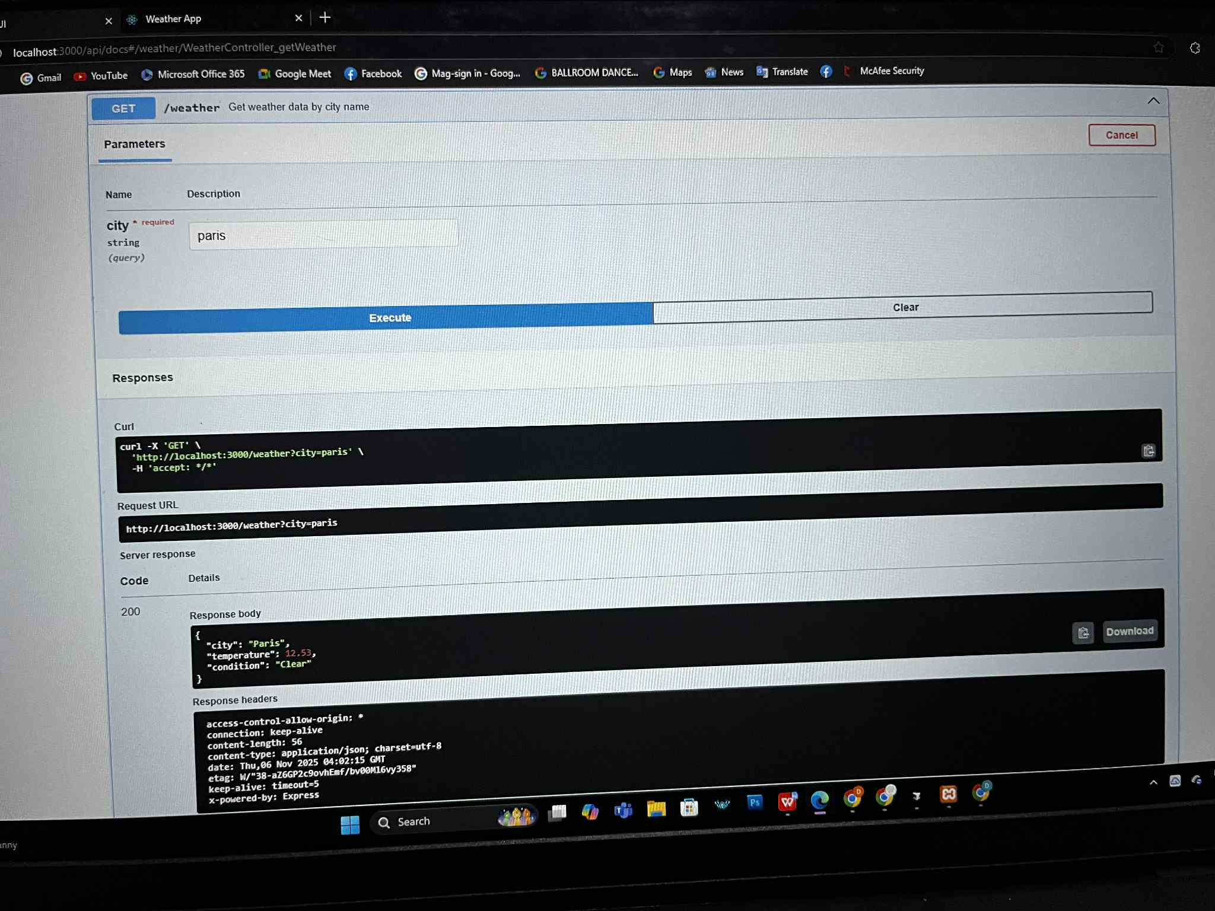
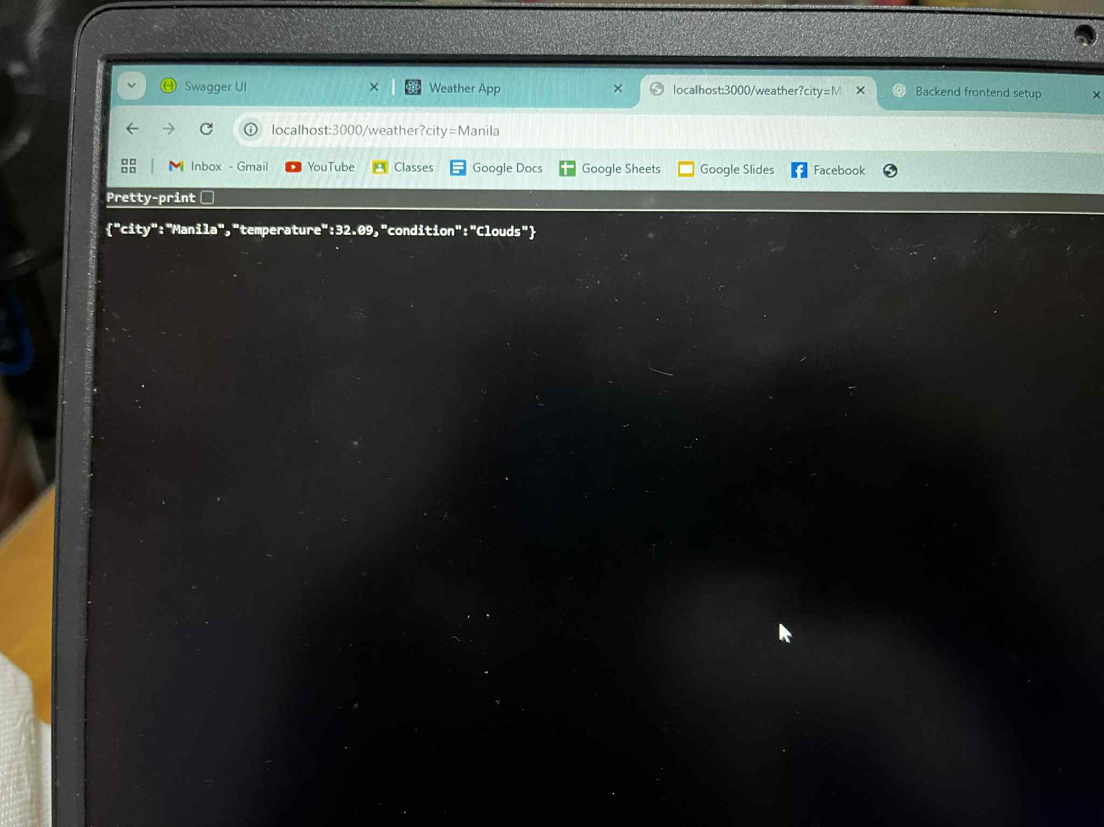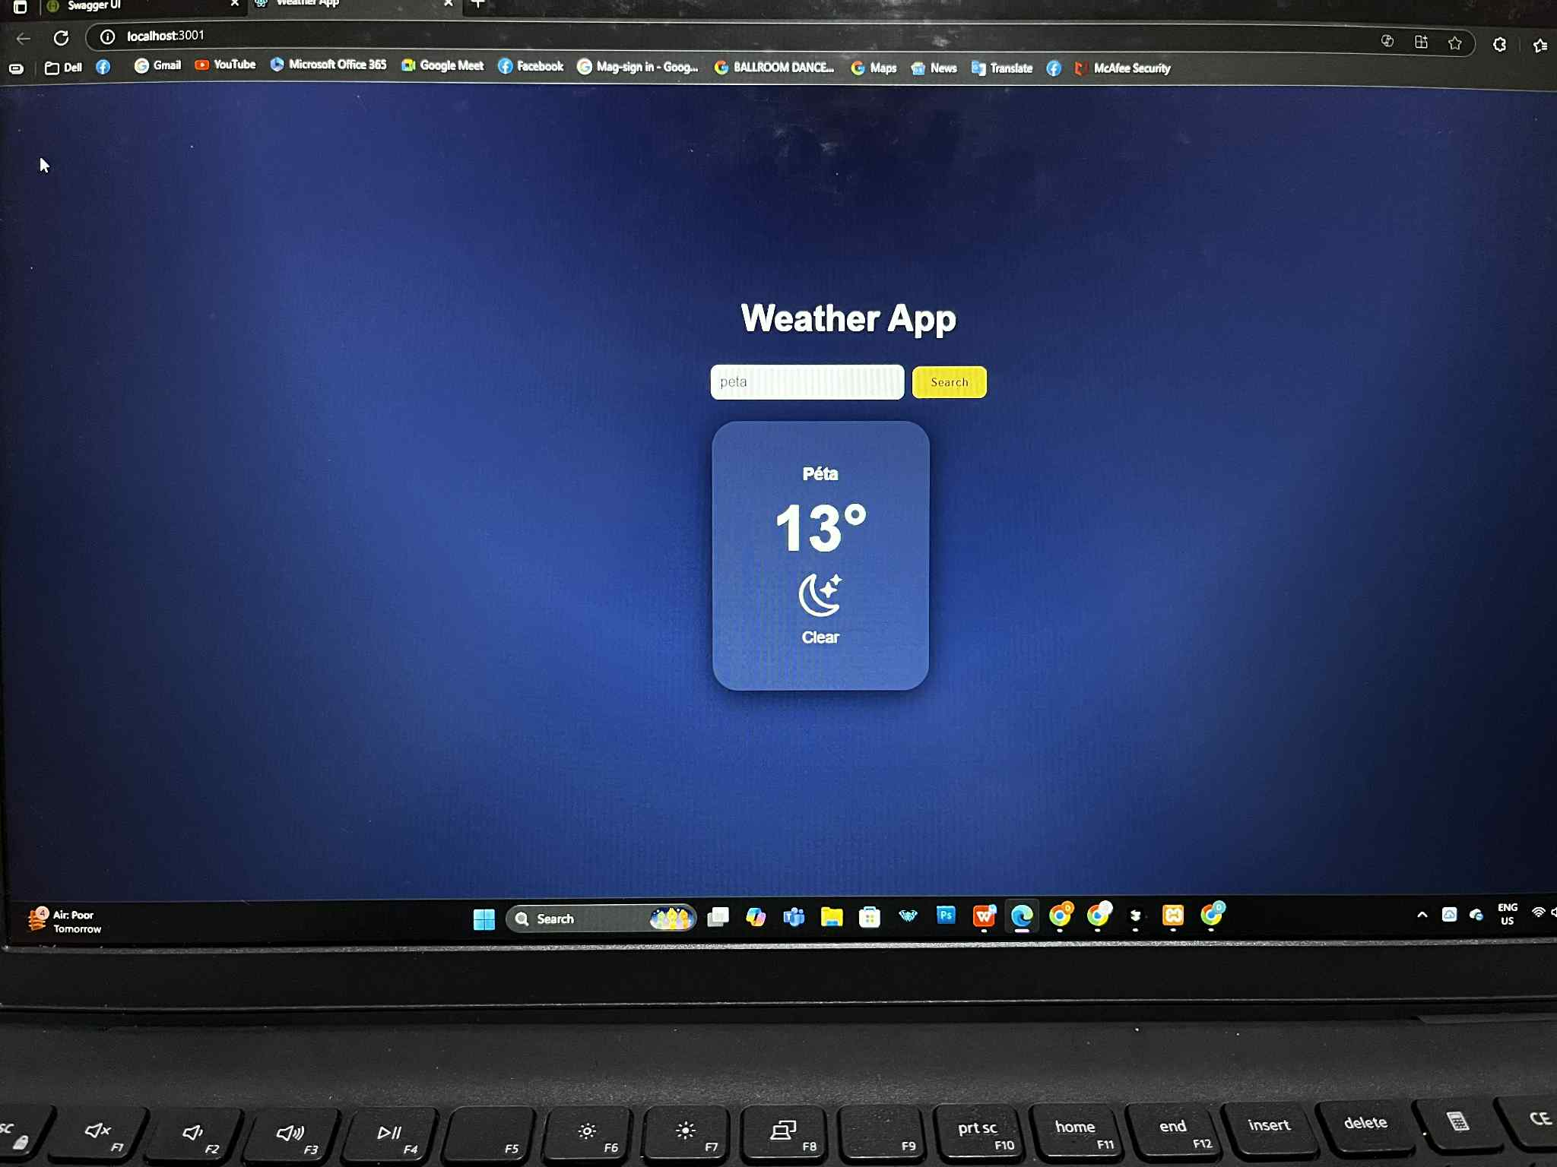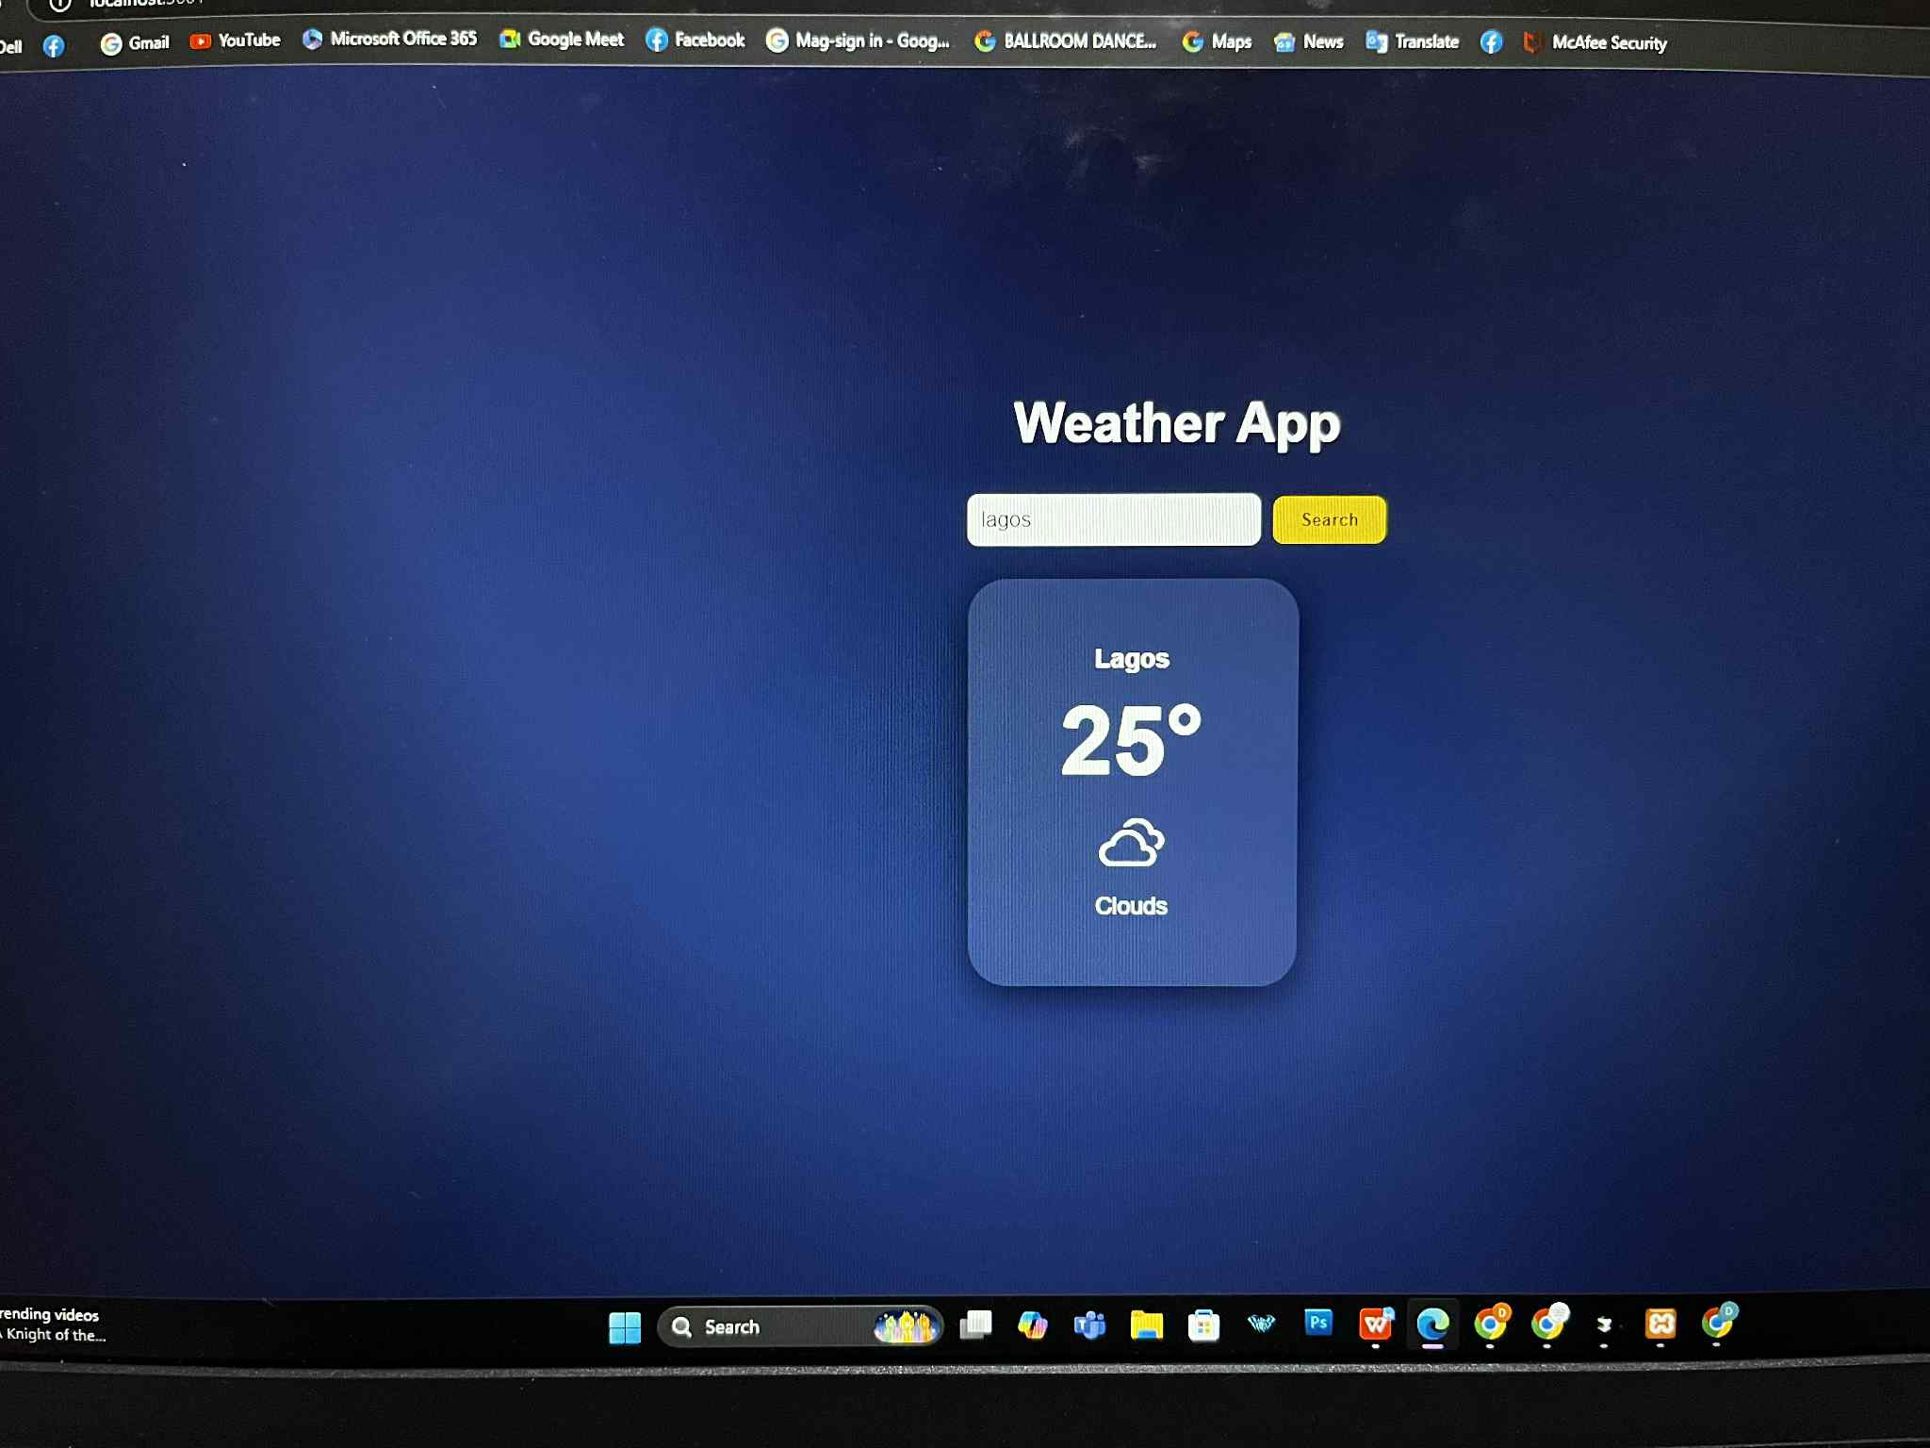

How to Run

Backend
- cd backend
- npm install
- Create a .env file inside the backend/ folder and add the following:
PORT=3000
OWM_API_KEY=247d907884ef8b64917db501e7a46ff8
DB_HOST=127.0.0.1
DB_PORT=3306
DB_USER=root
DB_PASS=
DB_NAME=activity 4
- npm run start:dev
- Once running, the backend will be available at:
http://localhost:3000
- To view the Swagger API documentation, open:
http://localhost:3000/api/docs

Frontend
- cd ../frontend
- npm install
- npm install @nestjs/axios axios
- npm install @nestjs/typeorm typeorm
- npm install @nestjs/swagger@10.3.1 swagger-ui-express --legacy-peer-deps
- npm install mysql2 --legacy-peer-deps
- npm start
- The app will open automatically in your browser at:
http://localhost:3001

API Endpoints
● GET / city

Submission Links
Backend: http://localhost:3000
Frontend: http://localhost:3001
Swagger:http://localhost:3000/api/docs
GROUP MEMBERS:
Abelita, Czyrell Gwen R.
Aranzasu, Darryl Jedidiah A.
Aranzasu Darrylene Kaela A.
Gangan, Demrose Carla C.
Moral, Andrie B.
Relox, Nathaniel

